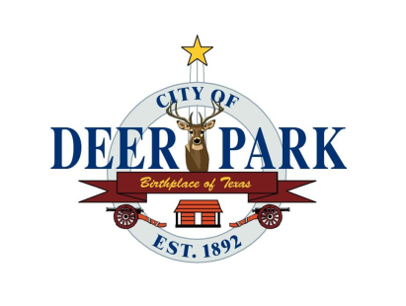

Economic Development Newsletter
DEER PARK, TEXAS

Let’s Make it a September to Remember; Shop & Dine Local

September 2025 • VOL. 107Vendors Needed
Vendors are needed for the 5th Annual Back the Blue BBQ Festival and 5K Fun Run occurring on Saturday, October 18 from 10AM to 5PM at Jimmy Burke Activity Center in Deer Park. Secure your spot for $75 and receive a table with two chairs, plus a prime spot at this heavily attended event. Contact Shaye Liter at (832) 454-2719 or email backthebluebbqfest@gmail.com. Find out more at www.backthebluebbqfest.org.

Home Grown

Stitched Salon is now open at 3414 Center Street (in the same retail center as Foodtown near the intersection of Pasadena Blvd.) Owner Lana Fillman has a passion for transforming hair into a canvas of art and elegance. Her stylists are Deer Park graduates, and they all bring their own expertise and flair to ensure that every guest leaves feeling their best. See their extensive website to learn more on services including hair, extensions, treatments and more at www.stitchedsalon.com or call them at (346) 671-4247. You can also email at LanaFillmanAndCo@gmail.com.

Gone But Not Forgotten
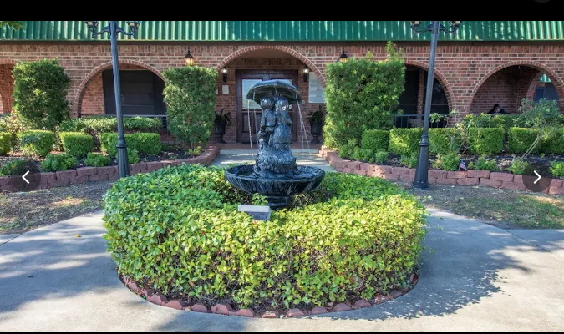
San Jacinto Manor Nursing Home, located at 206 W. P Street, was among the hardest-hit sites during the January 2023 tornado, which displaced more than 60 senior residents and nearly 100 staff members. Since then, the building has remained vacant, but the difficult decision was recently made to demolish it entirely. Opened in 1988, San Jacinto Manor served the Deer Park community for decades, providing compassionate care to countless families and their loved ones. While the future of the property remains uncertain, what is certain is the lasting impact of this facility and the dedicated staff who made it such a special place.


Every Friday!
Somethin’ Sweet is serving up a delicious deal every Friday — Buy One, Get One Free cupcakes from 3PM to 5PM. New owner Kristin Maresh recently introduced this weekly BOGO special, and it has quickly become a customer favorite. Kristin purchased the bakery at 118 Dixie Dr. just one year ago, and since then she’s made Somethin’ Sweet better than ever with fresh daily lunch specials, hearty soups, keto-friendly cookies, decadent cupcakes, holiday hams, and more. For updates and mouthwatering specials, follow them on Facebook at @Somethin’Sweet or call (281) 476-4441 to place your order.


Getting the Job Done
Deer Park is home to Hardline Services, a unique industrial safety provider that offers a variety of services including hazardous remediation, industrial cleaning, transfers and other safety-related expertise. Located at 2654 Center St., the owner is Ventura Gil (husband of Frosting Dreams bakery owner, Ashley Gil). The company works on location nationwide and approaches each job with precision and control. Contact Ventura at (346) 877-8083 or see their complete line of services at www.hardlinesvs.com.

Seeking Stylists

Salon Mia Bella is currently seeking talented and motivated stylists to join their team, with openings for both commission based and booth rental positions. Interested folks should apply in person at the salon, which is at 2808 Center St. The salon’s owner, Kim Coots, opened the salon as a “leap of faith” in February 2008 with one goal; to create a space where women could not only feel beautiful on the outside, but also be uplifted and ministered to on the inside. Her current team is committed to excellence, and she is hoping to add stylists that are passionate about hair and eager to grow in a supportive, upbeat environment.

Small Office Space Available
Now available is this single office space that sits near Hwy. 225 and this spot has a high traffic count. Dr. Marc Lefkowitz is leasing the office space in his building at 212 Center St. The office is 15' x 30' and includes a bathroom and closet. Tenant pays monthly rent plus electricity. Interested folks should call Dr. Lefkowitz at (281) 479-8386.

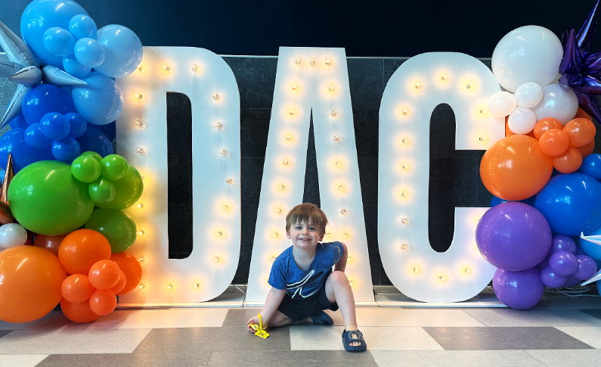
Now Open: Your New Happy Place!
We’re excited to announce the grand opening of the Dow Activity Complex (DAC) at 610 E. San Augustine in Deer Park—located next to City Hall and adjacent to Dow Park. This brand-new, 66,393 square foot state-of-the-art facility replaces the former Deer Park Community Center, and was made possible thanks to the 2021 voter-approved bond election. The DAC is a shining example of how community support can create lasting, positive change. Some facility highlights include an indoor exercise pool, pickleball, basketball, and volleyball courts, an indoor walking track, 4,500 square foot fitness floor with the latest exercise equipment, exercise/dance rooms, lounge, child watch rooms and so much more. Stop by to take a tour and become a member. Hours are M-F 6AM-9PM, Saturday 9AM-5PM and closed Sundays. For more information, call (281) 478-2050.

Bits & Pieces
- Be sure to support our local vendors on September 27 from 2PM to 7PM at Woofstock 2025 in Dow Park (610 E. San Augustine). The event is an annual, free community pet adoption event with tons of fun for the entire family.
- Center Street Professional Building will have an Open House/Ribbon Cutting on September 5 from 3PM to 5PM at 2318 Center St. (near the intersection of San Augustine St.) The building still has plenty of office space for lease. Come take a tour and enjoy food, games, raffles music and more.
- Apex Gym recently expanded their 50,000 sq. ft. gym at 9701 Spencer Hwy. by adding another 12,000 sq. ft. and over 100 pieces of new gym equipment.
- Fun Fact: Texas has the largest convenience store in the world; Buc-ee’s in Luling, TX at 75,593 square feet.
- Fun Fact: There are more than 10 million vehicle miles of daily commercial truck traffic collectively driving each day in the Houston region. That is enough mileage to encircle the Earth 401 times.
Thank you for reading. To see past issues of this bi-monthly newsletter, visit www.deerparktx.gov/ed. To subscribe, submit ideas or comment, email Debbie Westbeld at dwestbeld@deerparktx.org. Subscribers receive this bi-monthly electronic newsletter via email.

Debbie Westbeld, Economic Development Administrator
City of Deer Park
710 E. San Augustine, Deer Park, TX 77536 Phone: (281) 478-2042
Email: dwestbeld@deerparktx.org Website: www.deerparktx.gov/ed

Get weekly updates – “Like” us on Facebook at Deer Park Economic Development\

